Lab No. 4
Decision Tree Classification algorithm

Aim: To implement the Decision Tree Classification algorithm on Dataset.

Objectives:
1. To understand and perform data preprocessing on the Wine Quality dataset.
2. To explore the dataset using univariate, bivariate, and multivariate analysis.
3. To identify duplicate records and potential outliers in the dataset.
4. To analyze the relationship between wine characteristics and wine quality using statistical and visual methods.
5. To implement a Decision Tree Classification model using the Entropy criterion for predicting wine quality.
6. To evaluate and visualize the performance of the Decision Tree model using accuracy, precision, recall, F1-score, confusion matrix, and tree visualization.

Dataset: winequality-red Dataset
Resources/Tools Used:
* Python
* Jupyter Notebook / Google Colab
* Pandas
* NumPy
* Scikit-learn
* winequality-red dataset in CSV format
* GitHub for code submission
Date of Performance: 18 August 2026
URL: https://github.com/Rashi-Karule/ML/tree/main/Practical4

1. Data Loading and Initial Inspection

Cell 1 — Import Libraries and Load Dataset
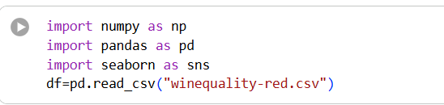
Imports NumPy, Pandas, and Seaborn libraries for data manipulation and visualization.
The winequality-red.csv dataset is loaded into a Pandas DataFrame named df.
This DataFrame is used for all further analysis.

Cell 2 — Display First Five Records
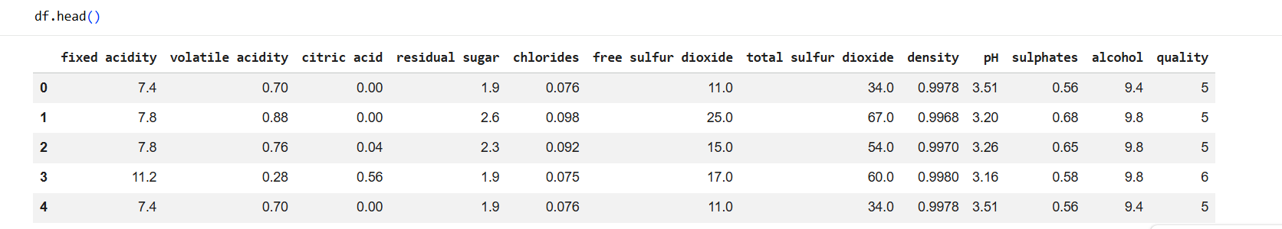
Uses df.head() to display the first five rows of the dataset. It helps to understand the structure, column names, and sample values. The dataset contains wine properties such as acidity, alcohol, sulphates, and quality.

Cell 3 — Display Last Five Records
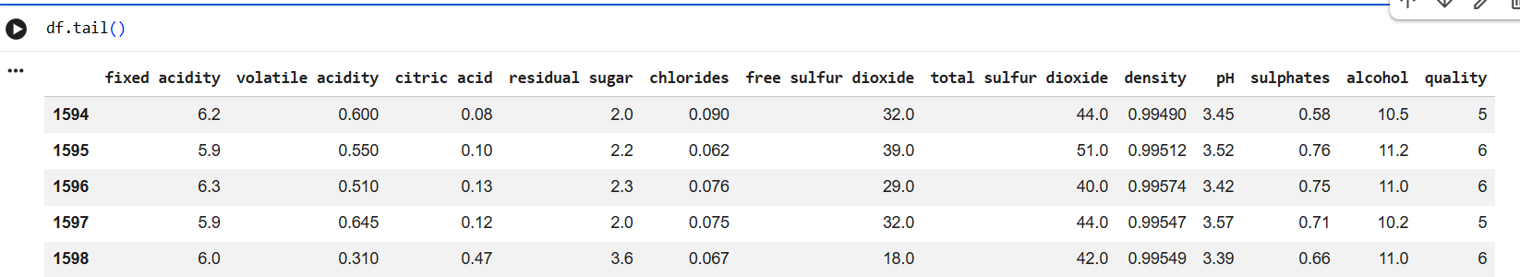
Uses df.tail() to display the last five rows of the dataset.This helps verify the ending records of the dataset. It also confirms that the data has been loaded correctly.

Cell 4 — Check Dataset Shape
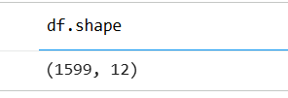
Uses df.shape to find the number of rows and columns.The dataset initially contains 1599 rows and 12 columns. This gives the overall size of the dataset.

Cell 5 — Display Dataset Information
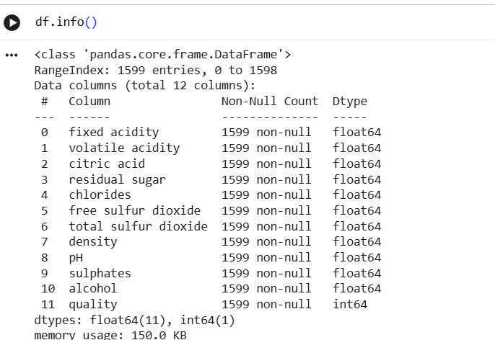
Uses df.info() to display column names, data types, and non-null counts.The dataset contains 11 floating-point columns and one integer column. It also shows that all 1599 records have non-null values.

Cell 6 — Generate Statistical Summary
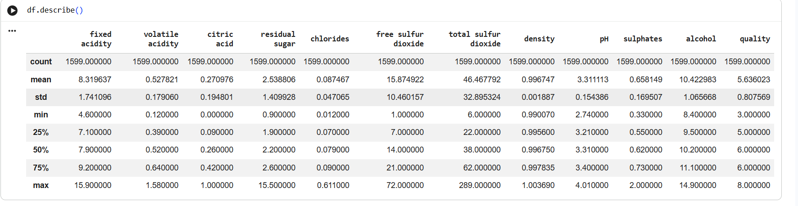
Uses df.describe() to calculate descriptive statistics for numerical columns. It displays count, mean, standard deviation, minimum, quartiles, and maximum values. This provides an overall understanding of the numerical distribution of the data.

Cell 7 — Check Missing Values
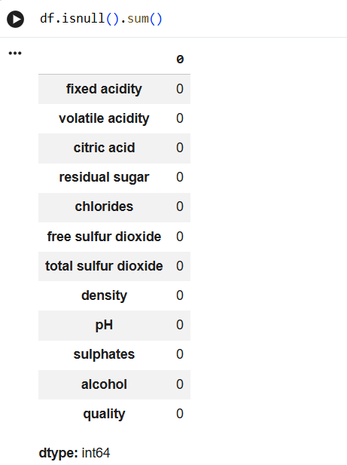
Uses df.isnull().sum() to count missing values in every column. The output shows zero missing values for all columns. Therefore, no missing-value treatment is required at this stage.

Cell 8 — Check Duplicate Records
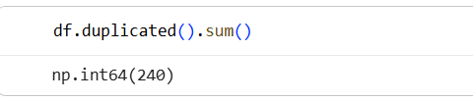
Uses df.duplicated().sum() to count duplicate rows. The dataset contains 240 duplicate records. This identifies duplicate data that should be removed before analysis.

Cell 9 — Remove Duplicate Records
Uses df.drop_duplicates() to remove all duplicate rows from the DataFrame. The cleaned DataFrame is stored back in df. This improves data quality by eliminating repeated records.

Cell 10 — Verify Duplicate Removal
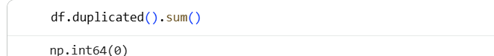
Runs df.duplicated().sum() again after removing duplicates. The result is 0, confirming that no duplicate rows remain. The dataset is now free from duplicate records.

Cell 11 — Display Column Names
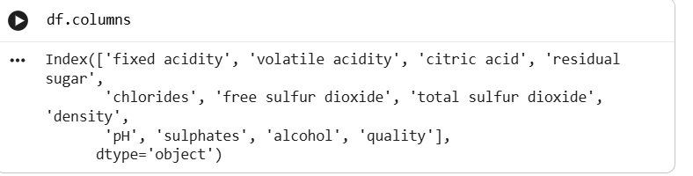
Uses df.columns to display all column names in the dataset. The columns represent different chemical properties of wine and its quality score. This helps identify the available features for further analysis.

2. Univariate Analysis

Cell 13 — Plot Distribution of All Features
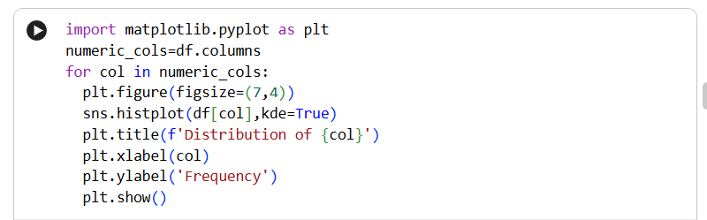
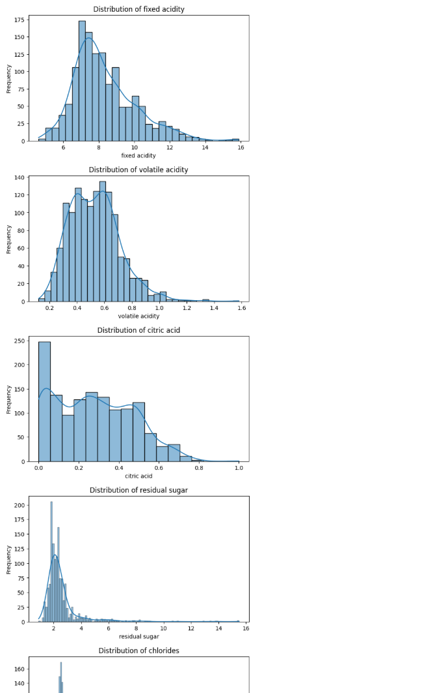

Imports Matplotlib and creates histograms with KDE curves for every numerical column. The loop generates one distribution plot for each feature in the dataset. This helps understand the frequency, spread, and distribution of individual variables.

Cell 14 — Generate Boxplots for Features
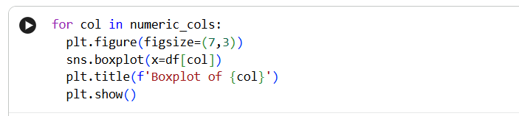
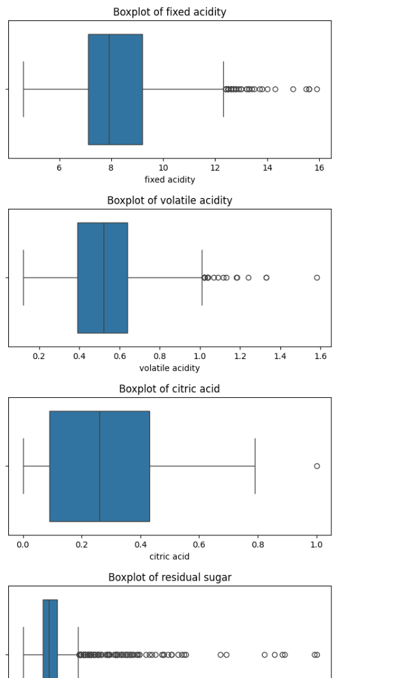
Creates a boxplot for every numerical column using Seaborn.Boxplots help visualize the median, spread, and potential outliers.This is useful for identifying unusual values in the dataset.

Cell 16 — Distribution of Wine Quality
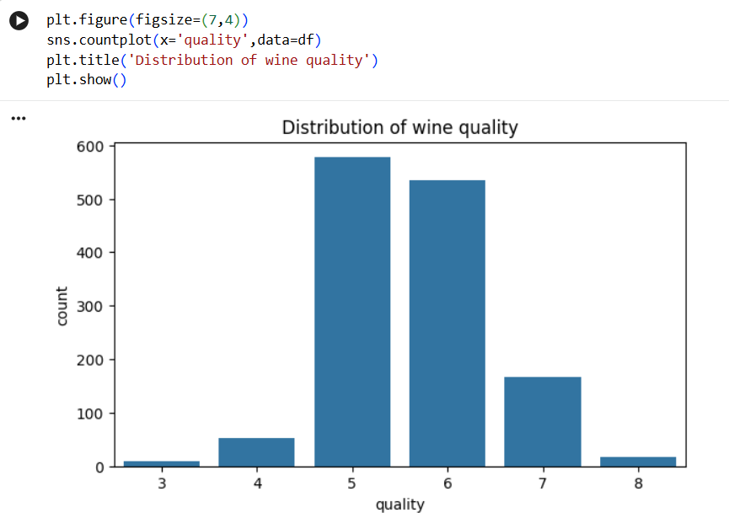
Uses a count plot to show the number of wines belonging to each quality level. The x-axis represents wine quality and the y-axis represents frequency. It helps understand how the quality classes are distributed.

Cell 17 — Count Quality Values
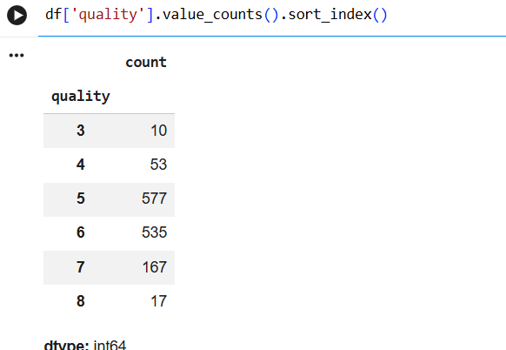
Uses value_counts().sort_index() to count wines for each quality score. The results are arranged in ascending order of quality. This gives the exact frequency of each wine quality category.

3. Bivariate Analysis

Cell 19 — Alcohol vs Wine Quality
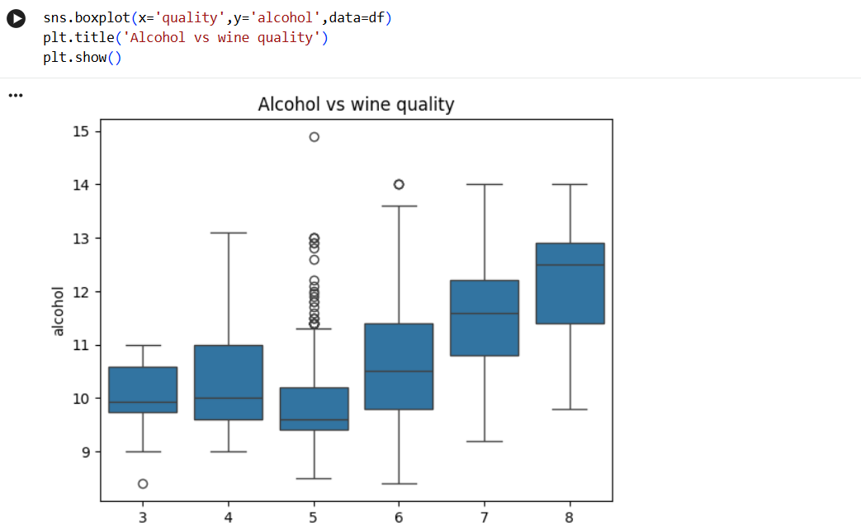
Creates a boxplot comparing alcohol content with wine quality. Wine quality is placed on the x-axis and alcohol content on the y-axis. This helps examine how alcohol levels vary across different quality scores.

Cell 20 — Display Dataset Head
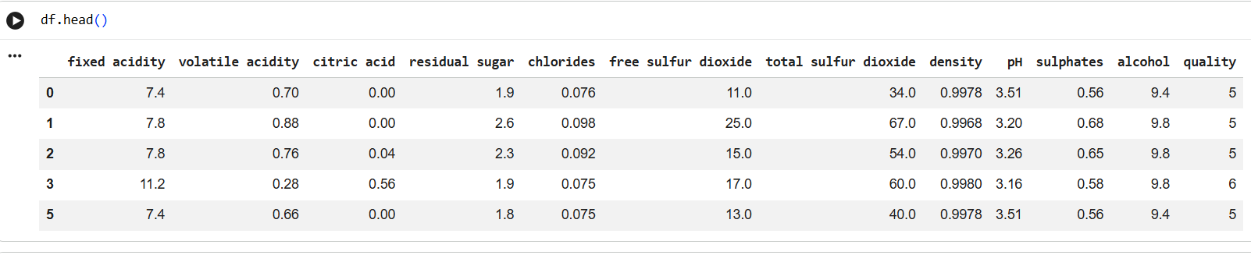
Uses df.head() to display the first five rows again. This provides a quick view of the cleaned dataset before further analysis. It also confirms the available features and target column.

Cell 21 — Compare Features with Wine Quality
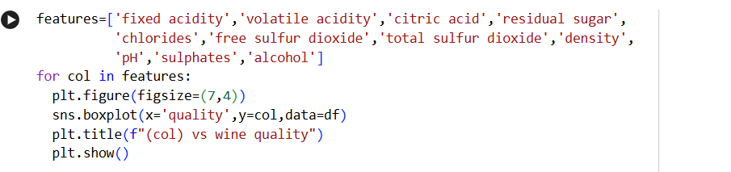
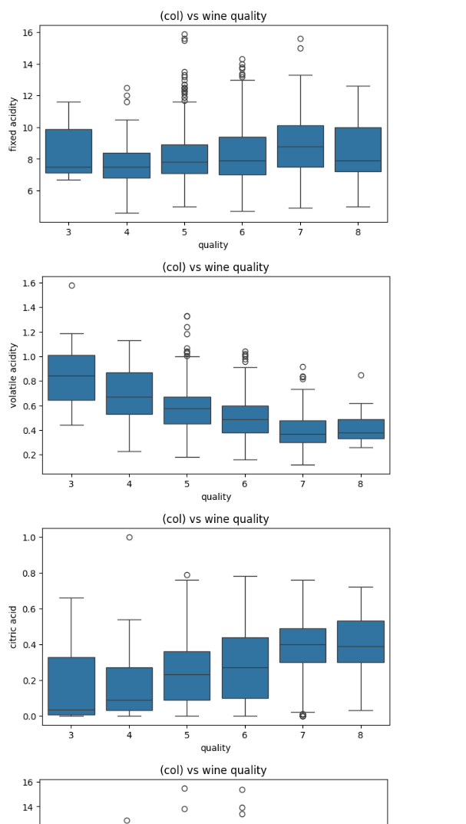
Creates boxplots for multiple wine features against wine quality. The loop compares each selected feature with different quality levels. This helps identify relationships and differences between features and wine quality.

Cell 22 — Detect Outliers Using IQR
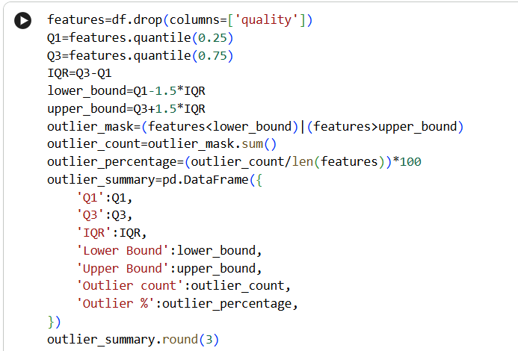
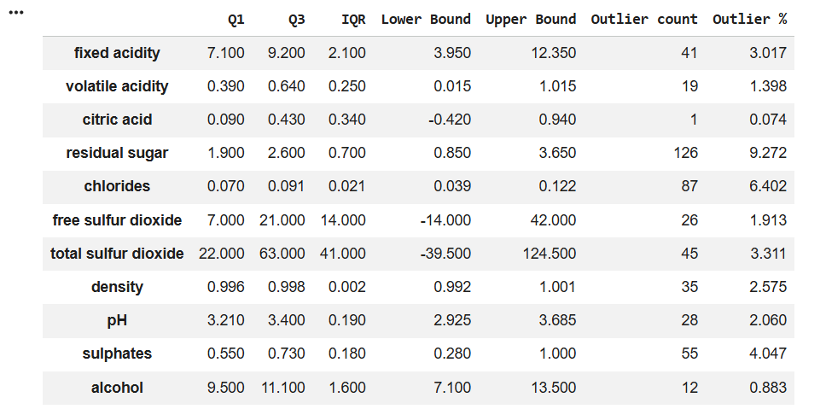
Calculates Q1, Q3, IQR, lower bounds, and upper bounds for each feature. It identifies values outside the IQR-based limits as potential outliers.An outlier summary DataFrame is created containing counts and percentages.

Cell 23 — Visualize Outlier Counts
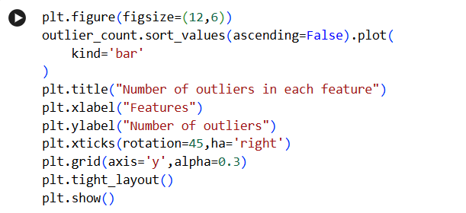
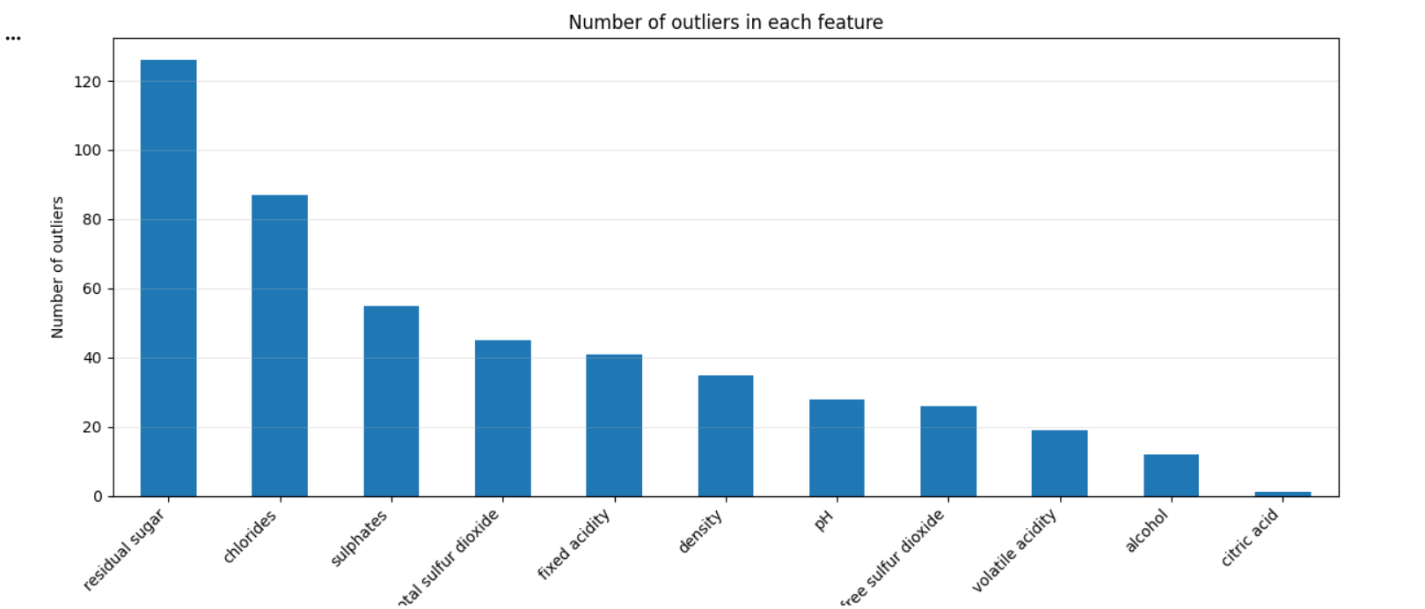
Creates a bar chart showing the number of outliers in each feature. Features are sorted according to their outlier counts.This makes it easier to identify which variables contain more potential outliers.

Cell 24 — Wine Quality Distribution
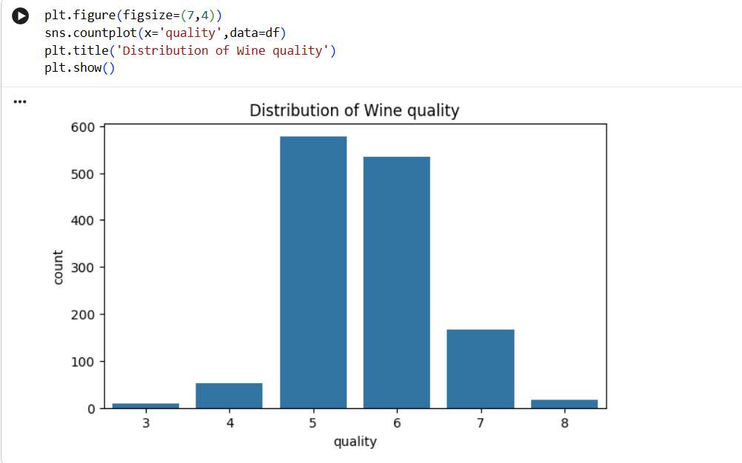
Creates another count plot for the wine quality variable. It displays the frequency of each quality level visually. This provides a graphical representation of the target variable distribution.

Cell 25 — Count Quality Categories
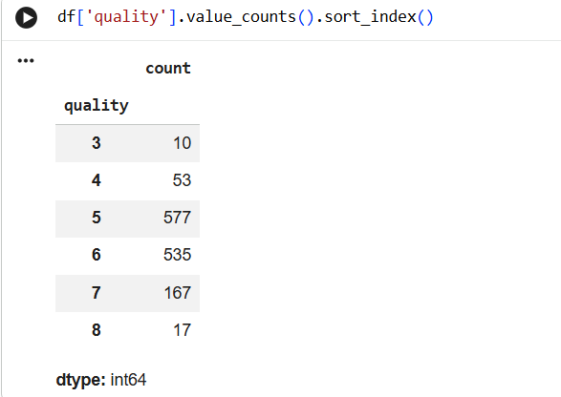
Uses value_counts().sort_index() to calculate the frequency of each wine quality score. The quality values are displayed in ascending order. This helps examine the distribution of the target variable numerically.

Cell 26 — Alcohol vs Quality Scatter Plot
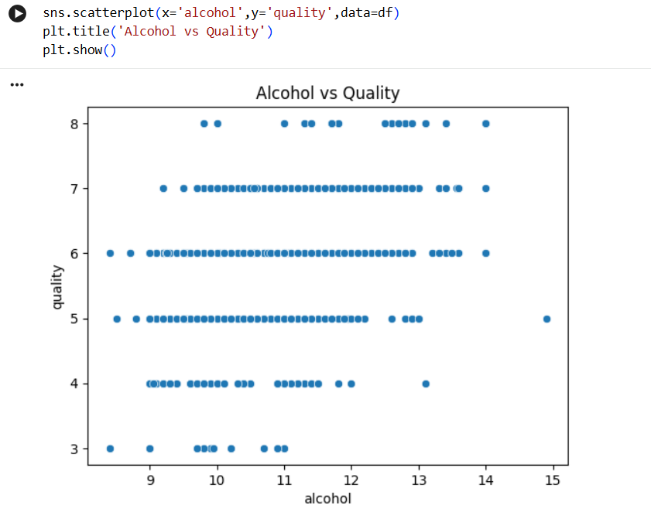
Creates a scatter plot between alcohol content and wine quality. Each point represents a wine record with its alcohol value and quality score.It helps visualize the possible relationship between alcohol and wine quality.

Cell 27 — Volatile Acidity vs Quality
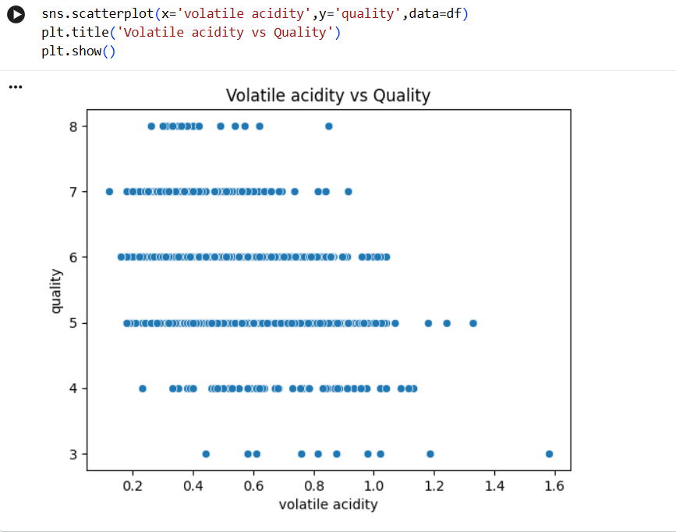
Creates a scatter plot between volatile acidity and wine quality. The plot shows how quality values vary with volatile acidity.It helps identify whether any visible relationship exists between these two variables.

4. Multivariate Analysis

Cell 29 — Correlation Heatmap
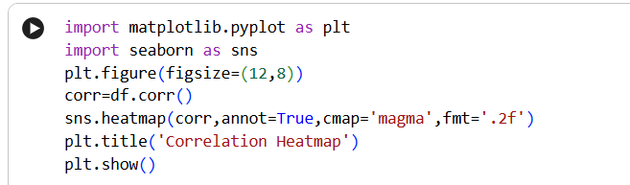
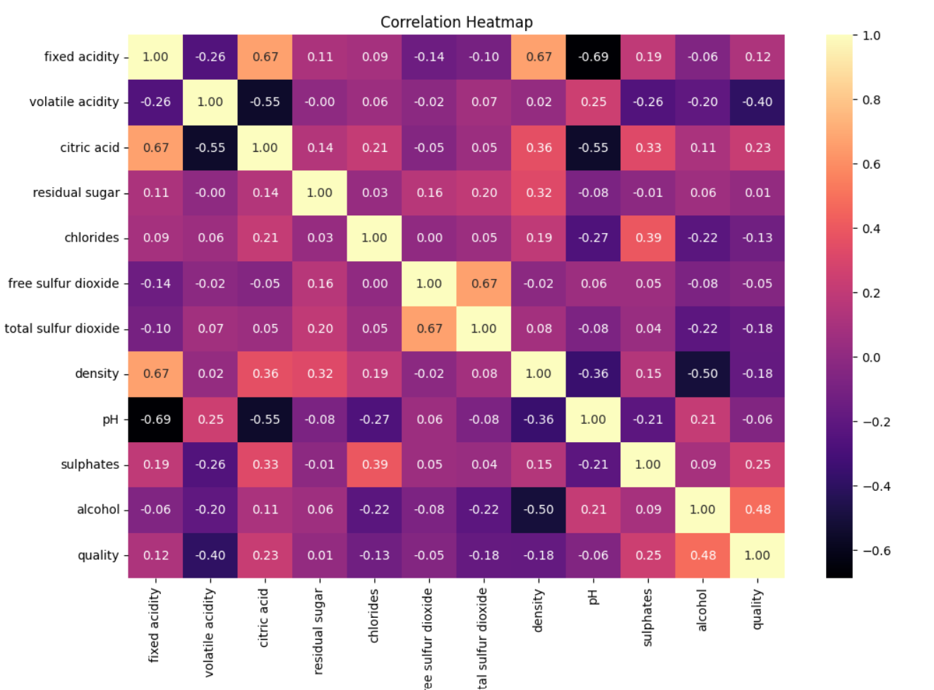
Calculates the correlation matrix for all numerical variables using df.corr(). A heatmap is then used to visually represent the correlations between features. This helps identify positively or negatively related variables.

Cell 30 — Pairwise Feature Analysis
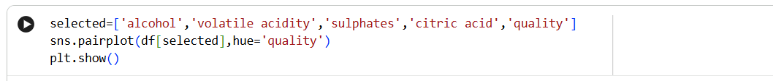
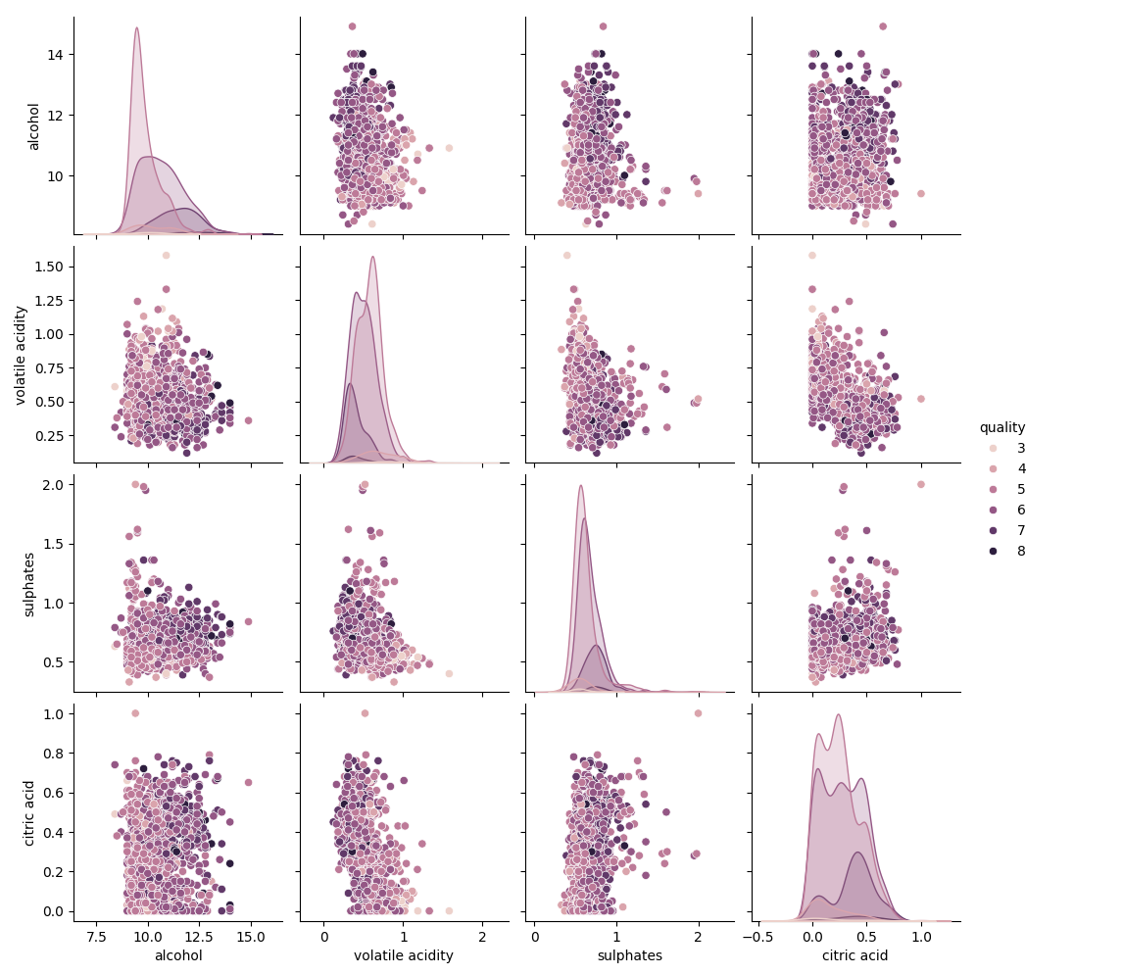
Selects alcohol, volatile acidity, sulphates, citric acid, and quality for analysis. A Seaborn pairplot is created to compare every selected variable with the others. The plots are grouped according to wine quality.

Cell 31 — Create Wine Quality Groups
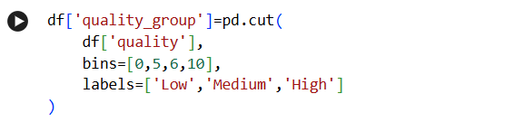
Uses pd.cut() to divide wine quality scores into three categories: Low, Medium, and High.
The new categorical variable is stored in quality_group. This simplifies the analysis by grouping individual quality scores.

Cell 32 — Alcohol Distribution by Quality Group
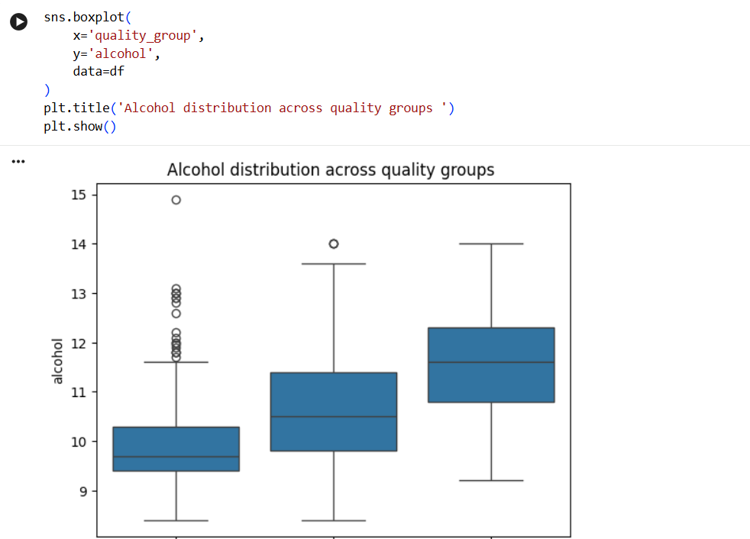
Creates a boxplot showing alcohol distribution for Low, Medium, and High quality groups. The x-axis represents quality groups and the y-axis represents alcohol content. This helps compare alcohol levels among different quality categories.

Cell 33 — Count Quality Groups
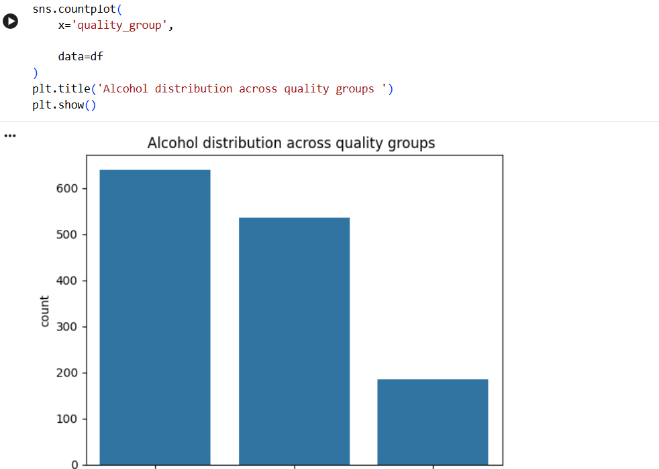
Creates a count plot for the newly created quality groups. It shows the number of wines in Low, Medium, and High categories. This helps visualize the distribution of grouped quality levels.

5. Decision Tree Classification

Cell 34 — Import Machine Learning Libraries
Imports train_test_split for splitting the dataset into training and testing sets. Imports DecisionTreeClassifier for building the classification model. Various evaluation metrics such as accuracy, precision, recall, F1-score, and confusion matrix are also imported.

Cell 35 — Separate Features and Target
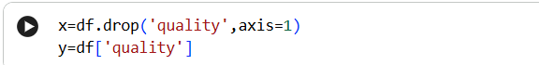
Creates x containing the input features by removing the quality column. Creates y containing the quality column as the target variable. This separates the independent variables from the value the model needs to predict.

Cell 36 — Check Feature and Target Shape
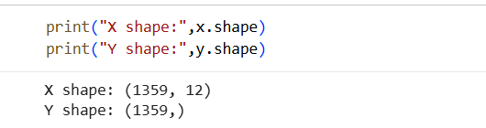
Prints the shapes of x and y. This verifies the number of records and variables being used for machine learning. It helps ensure that the features and target have matching numbers of observations.

Cell 37 — Check Target Distribution
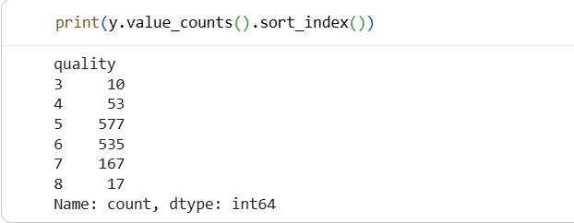
Uses value_counts().sort_index() to display the number of samples for each quality score. This helps understand the distribution of the target classes. It is useful before performing classification.

Cell 38 — Split Dataset into Training and Testing Sets
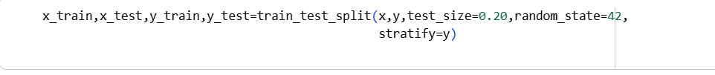
Uses train_test_split() to divide the data into training and testing sets. The test size is set to 20%, while random_state=42 ensures reproducibility. stratify=y maintains a similar quality-class distribution in both sets.

Cell 39 — Set Decision Tree Criterion
Defines the criterion as entropy. Entropy measures the impurity or uncertainty used by the decision tree for splitting. This criterion will be used while constructing the Decision Tree model.

Cell 40 — Create Initial Decision Tree Model
Creates a DecisionTreeClassifier using the entropy criterion. random_state=42 is used to make the model results reproducible. This model is prepared for classification of wine quality.

Cell 41 — Create Quality Groups Again
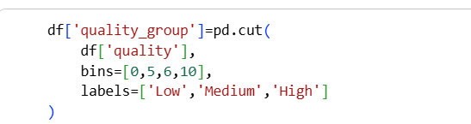
Again creates the quality_group column using pd.cut(). The quality scores are divided into Low, Medium, and High categories. This column is later excluded from the machine-learning features.

Cell 42 — Display Feature Columns
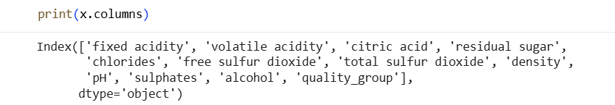
Prints the names of the columns currently present in x.This is used to check which variables are being used as model inputs. It helps verify that the feature selection is correct.

Cell 43 — Check Non-Numeric Features
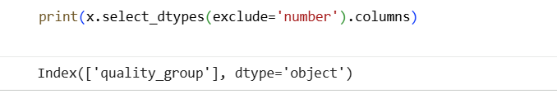
Uses select_dtypes(exclude='number') to find non-numerical columns in x. This checks whether any categorical variables could cause problems for the Decision Tree. It helps verify that the model inputs are numerical.

Cell 44 — Reset Target Variable
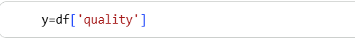
Sets y again to the quality column. This ensures that wine quality is correctly assigned as the classification target. The target is ready for the final model-training process.

Cell 45 — Remove Target and Quality Group
Creates x by removing both quality and quality_group columns. This ensures that the target variable and derived quality group are not used as input features. The remaining columns are used as independent variables.

Cell 46 — Verify Features and Data Types
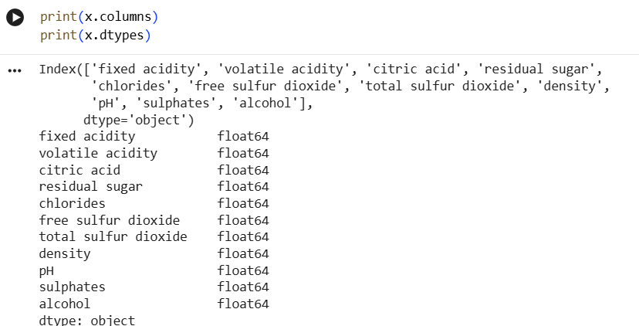
Prints the feature column names and their corresponding data types. This confirms that the model inputs are numerical and correctly selected. It is a final check before splitting the data.

Cell 47 — Final Train-Test Split
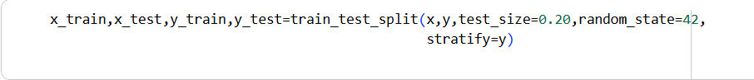
Splits the cleaned features and target into training and testing datasets. 20% of the data is reserved for testing and 80% is used for training. Stratification maintains the distribution of quality classes.

Cell 48 — Display Dataset Split Shapes
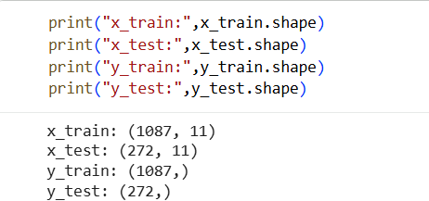
Prints the shapes of x_train, x_test, y_train, and y_test. This verifies that the training and testing datasets were created correctly. It also confirms the number of samples available for model training and evaluation.

Cell 49 — Train Decision Tree Model
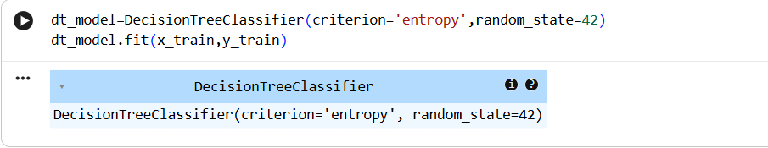
Creates a Decision Tree classifier using the entropy criterion. The model is trained using x_train and y_train with the fit() method. The trained model can now predict wine quality.

Cell 50 — Generate Predictions
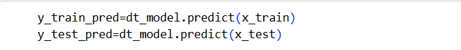
Uses the trained Decision Tree to predict quality for both training and testing data. The predictions are stored in y_train_pred and y_test_pred. These predictions are used to calculate model performance.

Cell 51 — Calculate Training Accuracy
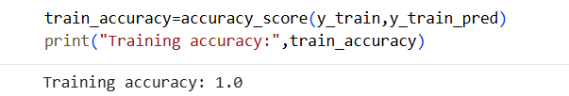
Calculates the accuracy of the Decision Tree on the training dataset. The output shows a training accuracy of 1.0. This means the model correctly classified all training samples.

Cell 52 — Calculate Testing Accuracy
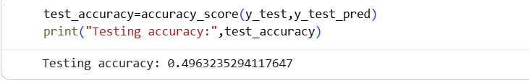
Calculates the accuracy of the model on unseen testing data. The testing accuracy obtained is approximately 49.63%. This indicates that the model performs considerably better on training data than testing data.

Cell 53 — Calculate Precision, Recall and F1 Score
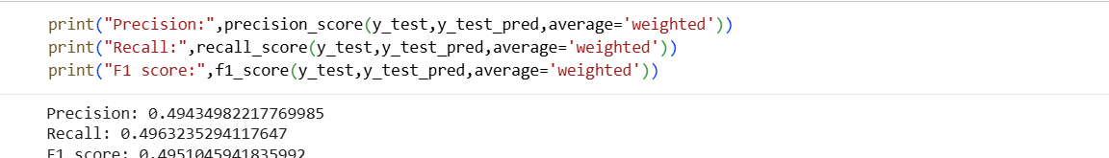
Calculates weighted precision, recall, and F1-score for the test predictions.These metrics provide additional information about classification performance. The notebook obtains approximately 0.49 for all three measures.

Cell 54 — Generate Classification Report
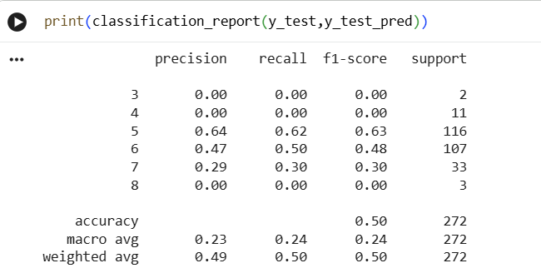
Uses classification_report() to display precision, recall, F1-score, and support for each quality class. It provides detailed performance for quality levels 3 through 8. This helps identify which quality classes the model predicts more effectively.

Cell 55 — Create Confusion Matrix
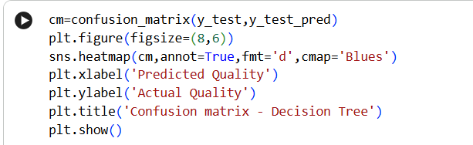
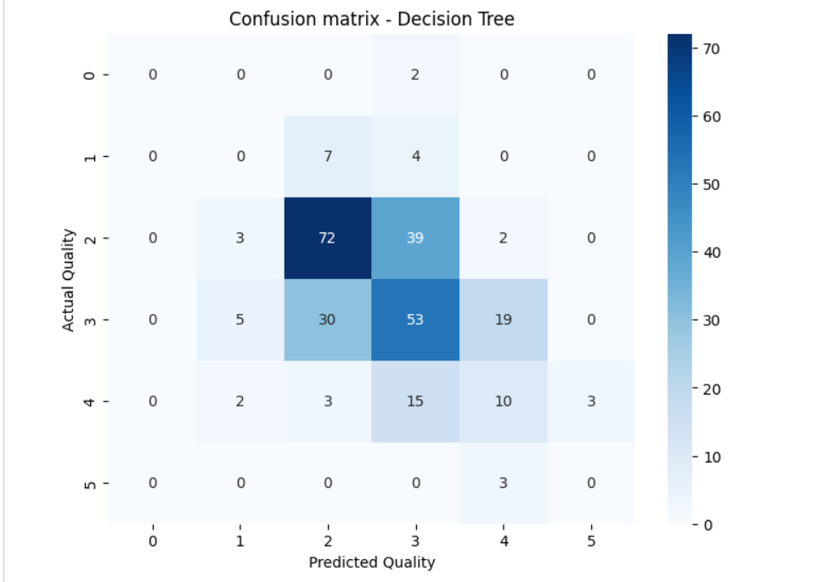
Calculates the confusion matrix using actual and predicted quality values. A Seaborn heatmap displays the matrix visually. It helps identify correct predictions and misclassifications for each quality class.

Cell 56 — Check Tree Complexity
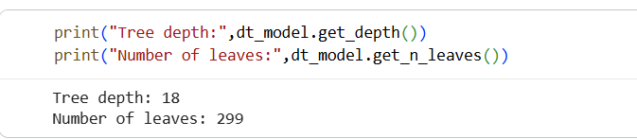
Uses get_depth() to find the depth of the trained Decision Tree. Uses get_n_leaves() to determine the number of leaf nodes. These values describe the complexity and structure of the trained model.

Cell 57 — Visualize Complete Decision Tree
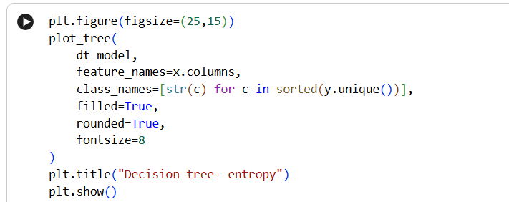
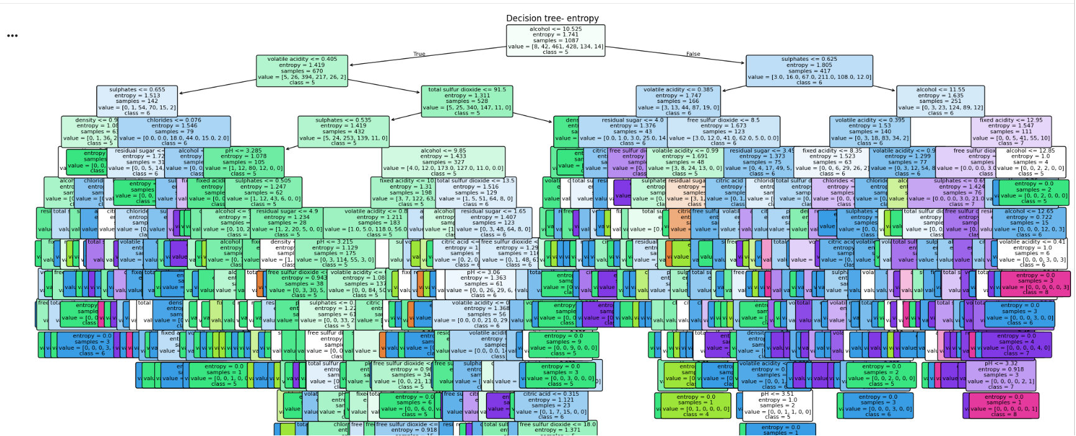
Uses plot_tree() to display the complete trained Decision Tree. Feature names and class names are included to make the tree easier to interpret. The visualization shows the decision rules used to classify wine quality.

Cell 58 — Visualize Top Three Tree Levels
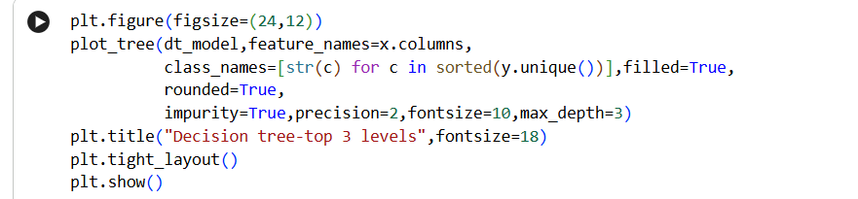
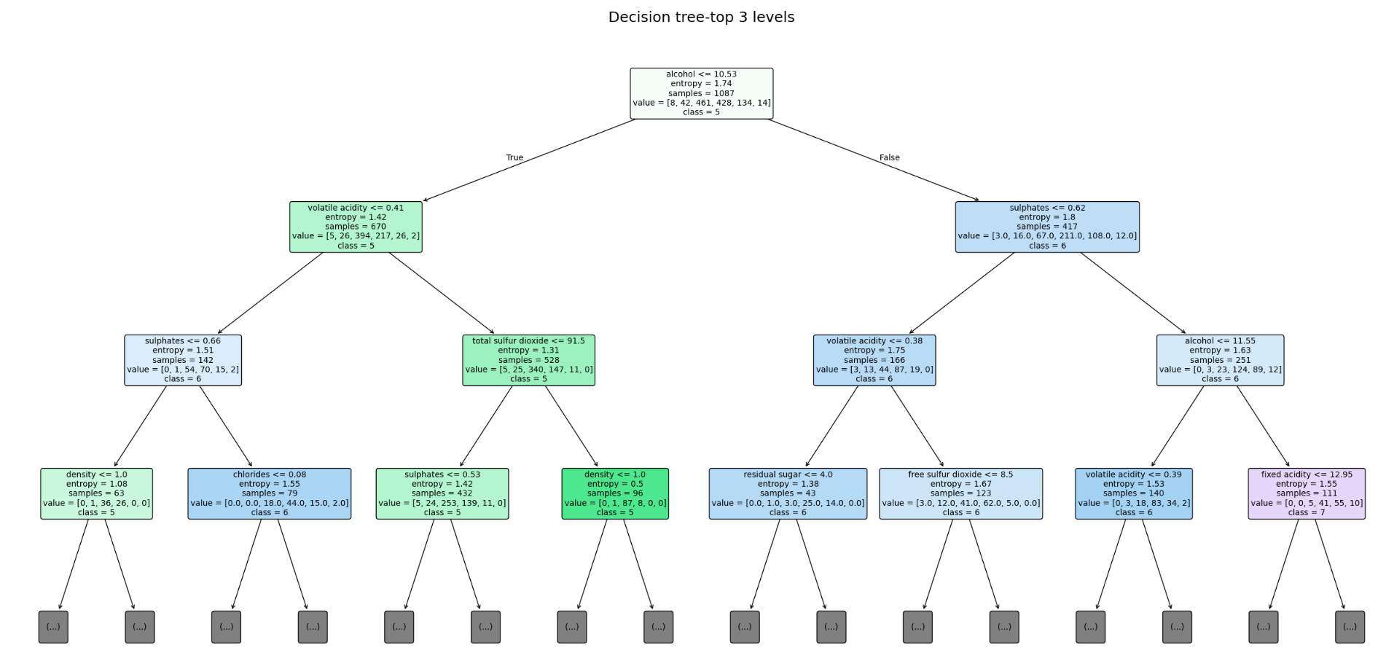
Plots only the first three levels of the Decision Tree using max_depth=3. This provides a simpler view of the most important initial decision rules. Impurity, class information, and feature names are displayed.

Cell 59 — Visualize Top Two Tree Levels
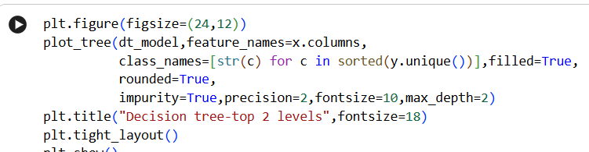
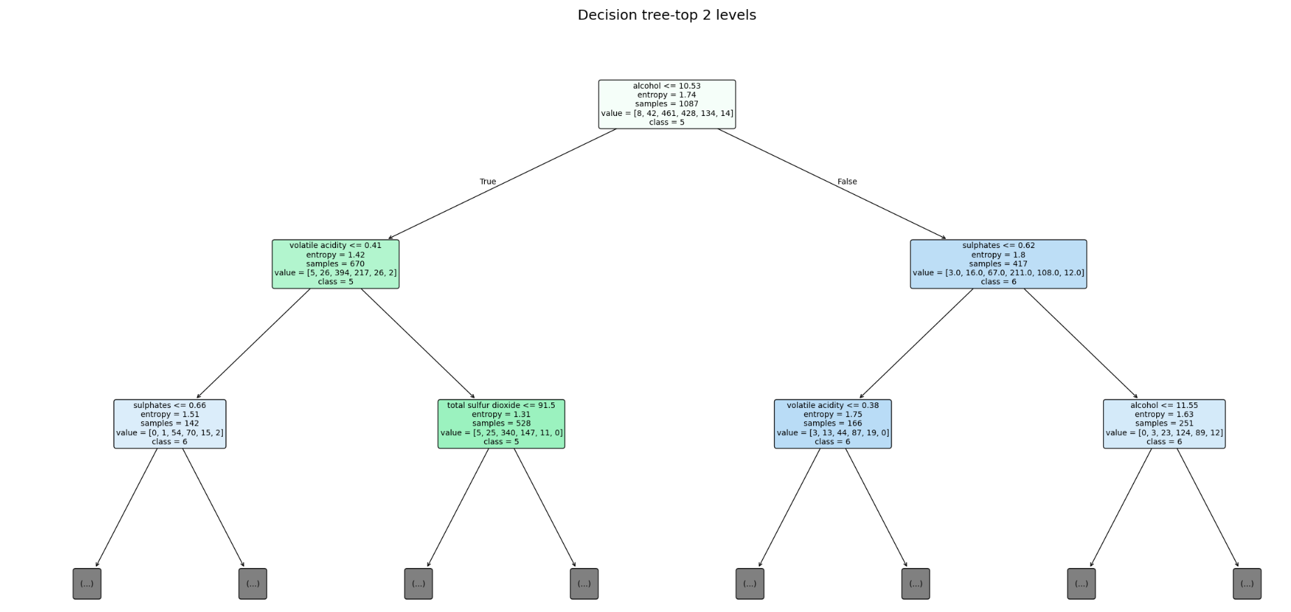
Plots only the first two levels of the Decision Tree using max_depth=2. This gives an even simpler representation of the main splits made by the model. It is useful for understanding the tree without displaying its entire structure.

Viva Questions

1. What is a Decision Tree?
A Decision Tree is a supervised machine learning algorithm used for classification and regression. It makes decisions by splitting the dataset based on different features. Each internal node represents a decision, branches represent outcomes, and leaf nodes represent the final prediction.

2. What is the purpose of the Entropy criterion?
Entropy is used to measure the impurity or uncertainty in a dataset. The Decision Tree selects splits that reduce entropy and make the resulting groups more pure. In this practical, the Decision Tree Classifier is created using the entropy criterion.

3. Why is the dataset divided into training and testing sets?
The training data is used to teach the Decision Tree model, while the testing data is used to evaluate it on unseen records. In this practical, 80% of the data is used for training and 20% for testing. Stratification is used to maintain a similar distribution of quality classes in both sets.

4. What is the difference between accuracy, precision, recall and F1-score?
Accuracy measures the overall percentage of correct predictions. Precision measures how many predicted positive/class results are actually correct, while recall measures how many actual class instances are correctly identified. F1-score combines precision and recall into a single measure.

5. What is a confusion matrix?
A confusion matrix is a table used to evaluate the performance of a classification model.
It compares the actual classes with the predicted classes. It helps identify which wine quality classes were correctly classified and which were misclassified.

